|  |  |  |  |  |  |  |  |  |  |  |  |  |  |  |  |  |  |  |  |  |
| --- | --- | --- | --- | --- | --- | --- | --- | --- | --- | --- | --- | --- | --- | --- | --- | --- | --- | --- | --- | --- |
| Image result for unikl logo  **MALAYSIAN INSTITUTE OF INFORMATION TECHNOLOGY**  **MARCH 2024**  **IBB 43203 CLOUD COMPUTING**  **GROUP PROJECT ASSIGNMENT**  **PREPARED BY:**   |  |  |  |  | | --- | --- | --- | --- | | **NO.** | **NAME** | **STUDENT ID NO.** | **HP NO.** | | **1** | **MUHAMMAD RAIMEE BIN ABDUL RAOFF** | **52222121137** | **018-363 5933** | | **2** | **AMIRUN AMIN BIN MOHAMAD ZAMANI** | **52224122595** | **013-918 6254** | | **3** | **KHAIRUL AFFANDI BIN NADZIRI** | **52222120767** | **018-228 4015** | | **4** | **MOHAMMAD FAUZAN BIN REDZUAN** | **52222120726** | **011-1023 4164** |   **PREPARED FOR:**  **MEGAT NORULAZMI MEGAT MOHAMED NOOR** |

Proposal Report

**Introduction**

The objective of this report is to provide evidence of the work conducted by the group members for the assignment given by Megat Norulazmi Megat Mohamed Noor. This project aims to deploy web application source code from GitHub on Microsoft Azure. The selected web application is a tip calculator, an open source React web app that allows users to easily calculate their purchase total, including tip and tax. This system is particularly useful for users at restaurants or cafeterias, saving time and effort in calculating the total amount with tip and tax included.

Below is a step-by-step guide on how to deploy web application source code from GitHub to Microsoft Azure.

**Team Members Role:**

Muhammad Raimee Bin Abdul Raof – Leader

Amirun Amin Bin Mohamad Zamani – Researcher

Khairul Affandi Bin Nadziri - Reseacher

Mohammad Fauzan Bin Redzuan - Video Editor

Youtube Video Link to Guidance Step by Steps on deploying web application source code from GitHub on Microsoft Azure.

<https://youtu.be/-XTpMNMSJgg>

[](https://youtu.be/-XTpMNMSJgg)

**Checking if the web app source code is useable or not.**

Find and open a suitable web app source code git hub tip calculator for group project.

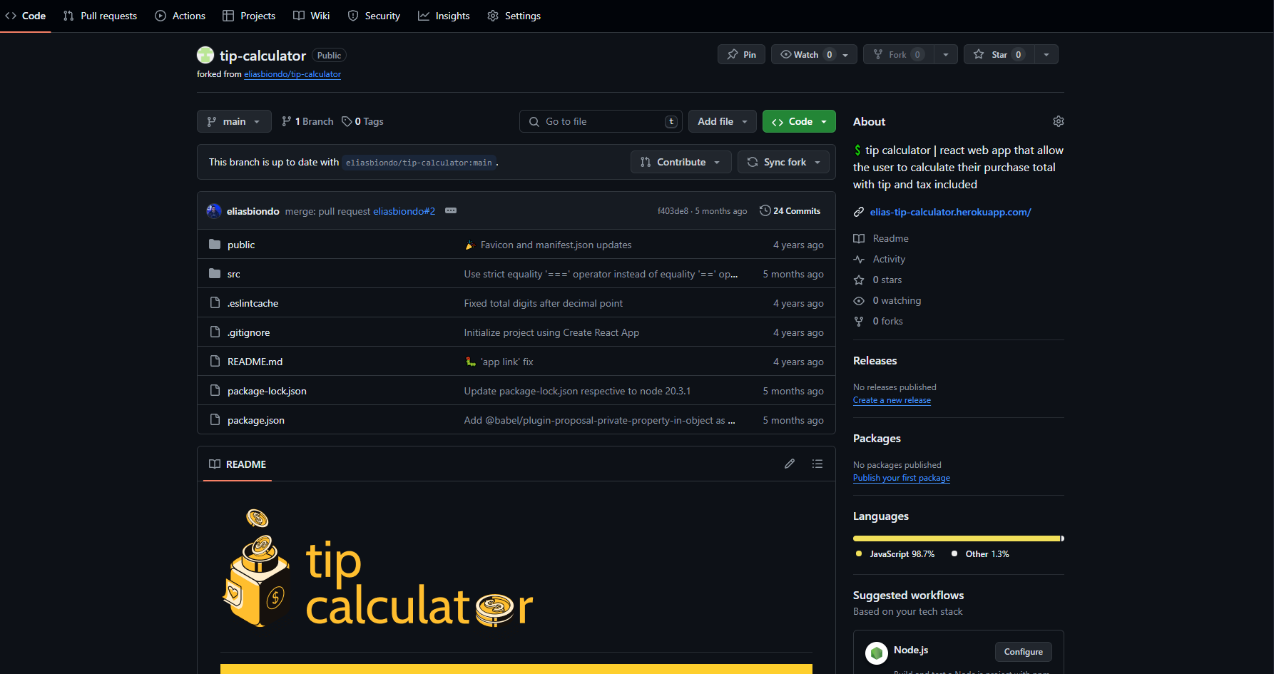

Open gitbash and enter command $ git clone <https://github.com/eliasbiondo/tip-calculator.git> to clone the repository to PC.

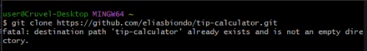

Then enter $ cd tip-calculator to move to tip-calculator folder area.

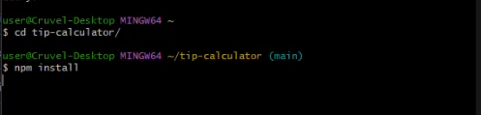

Enter command $ npm install to install npm software. If failed or memory leak, install npm by specific version (npm install / npm install npm install -g [npm@10.8.1](mailto:npm@10.8.1)).

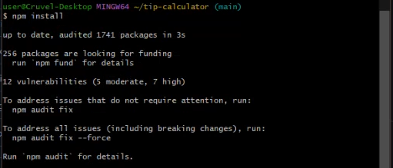

Next, enter $ npm start command to start the deployment of the website to check if the web app source code exist and able to be used.

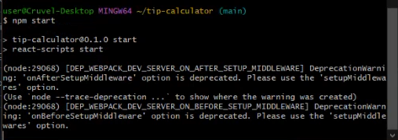

After the command npm start, it will pop up like this:



**Deploying web application source code in GitHub in Microsoft Azure**

Get azure sandbox to be enabled

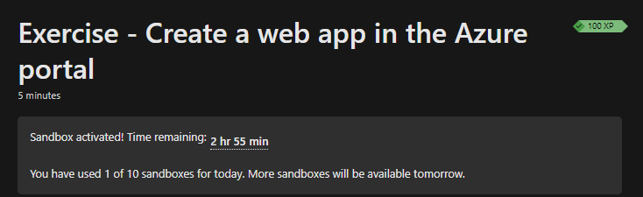

Visit azure portal

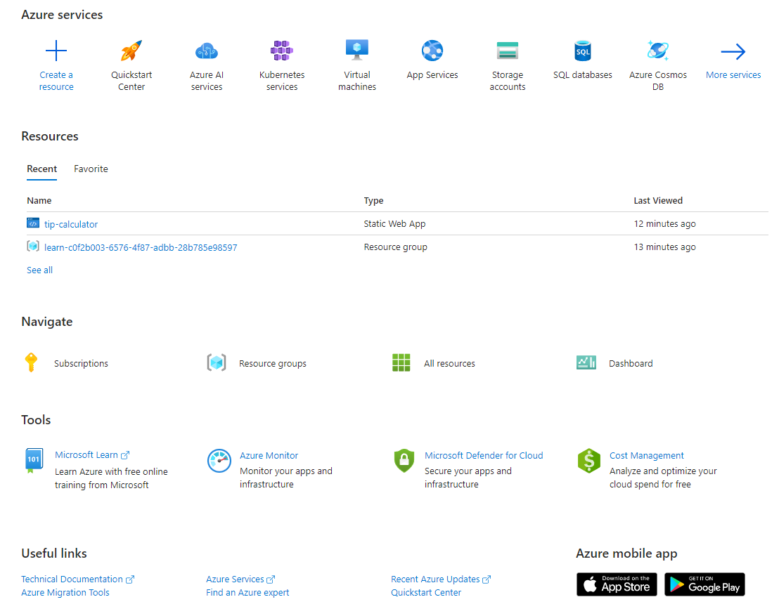

Create a resource and find static web app and then create.

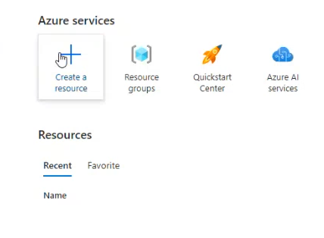

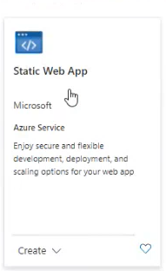

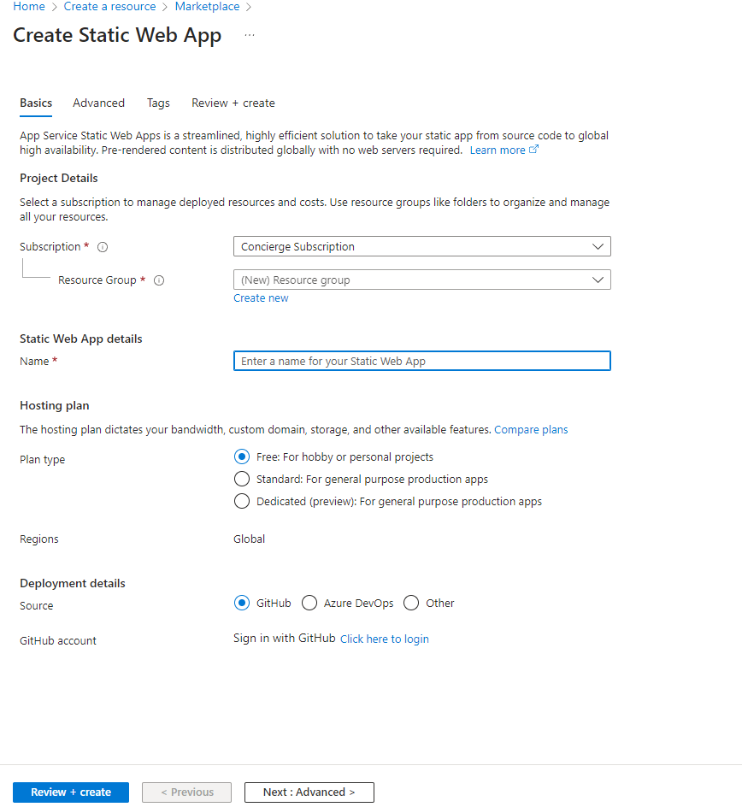

Open tip calculator GitHub again and forked/ copy it to account

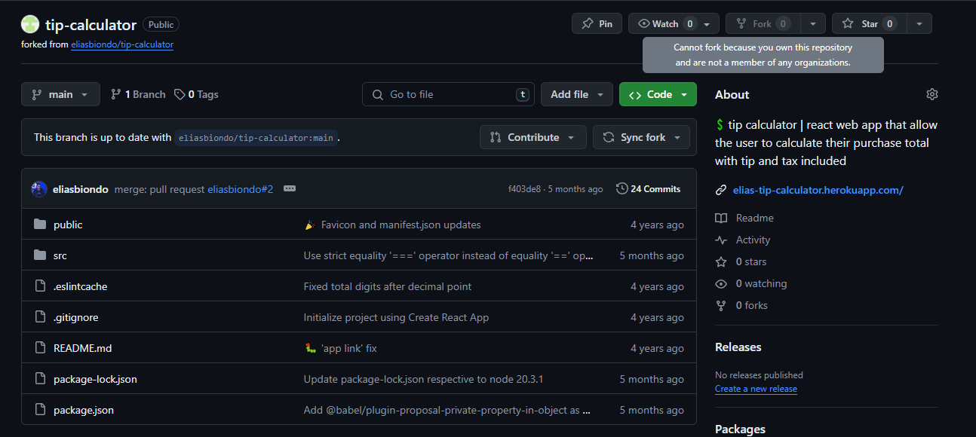

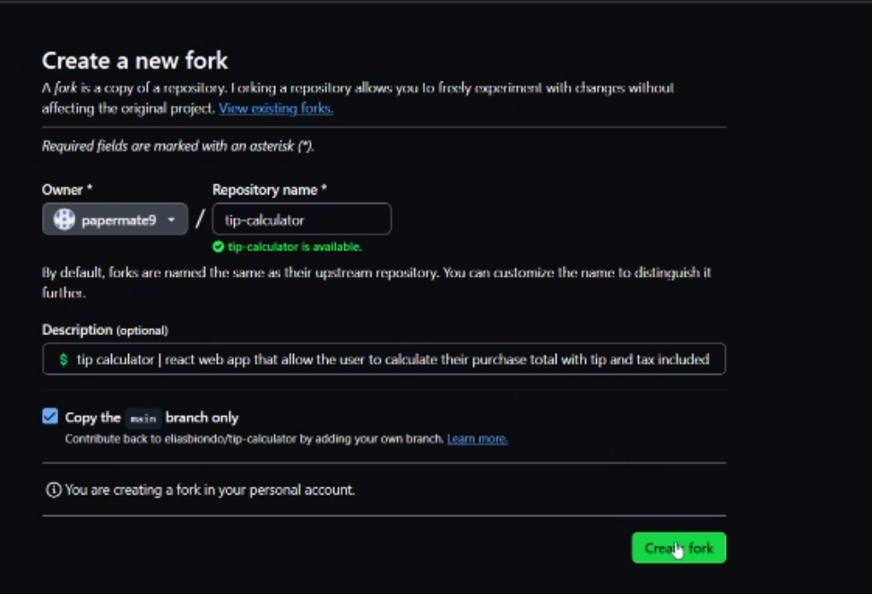

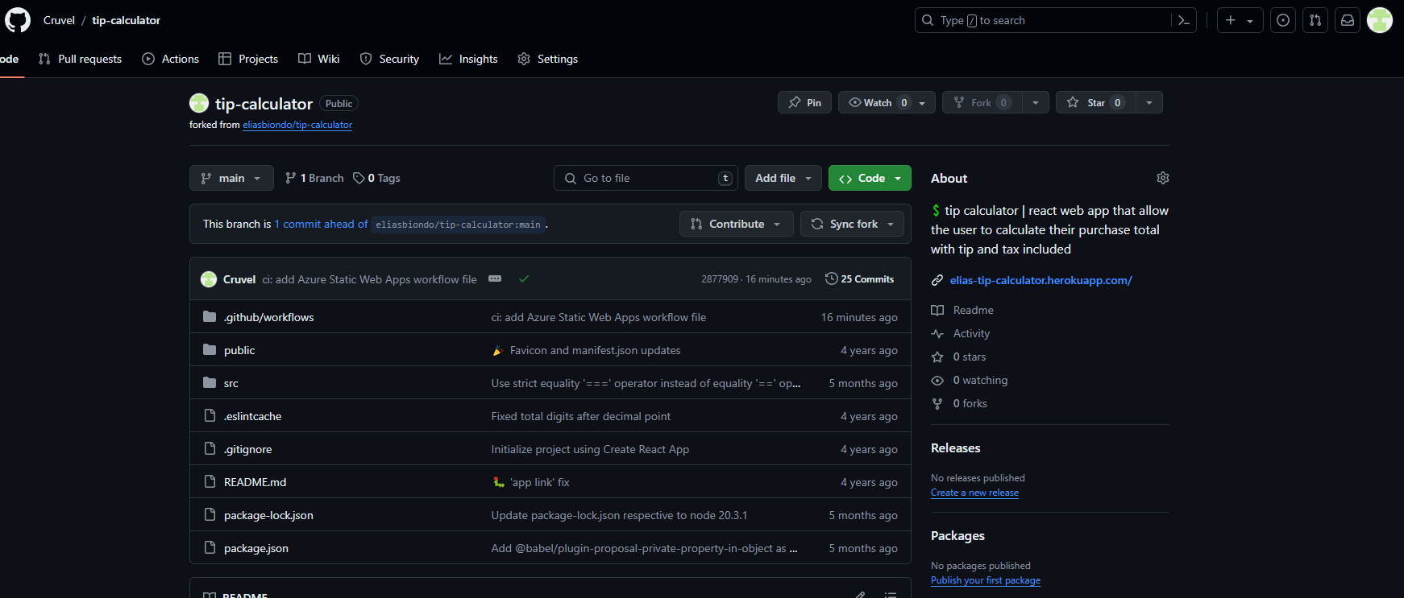

Return to Azure static web app and login to GitHub account on deployment details

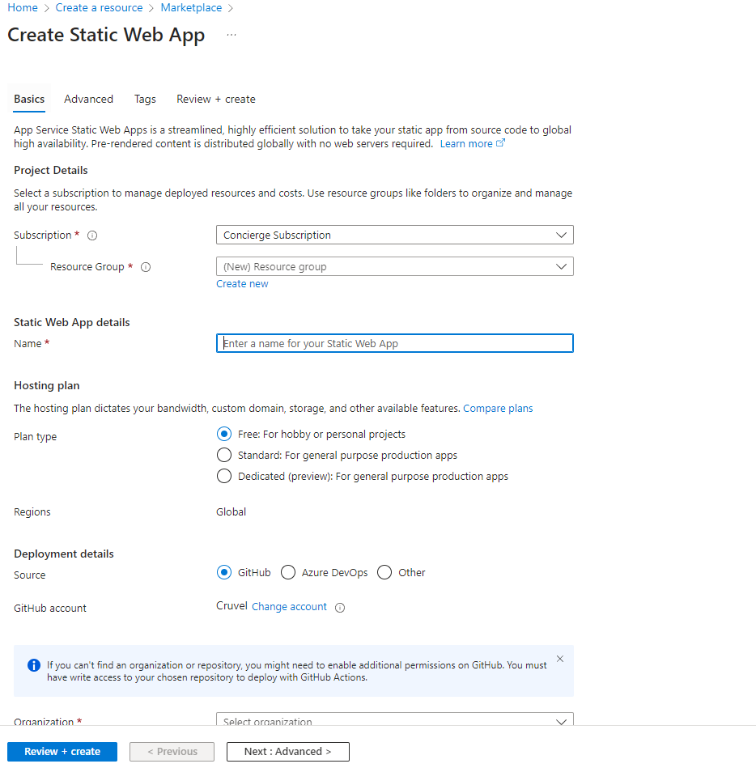

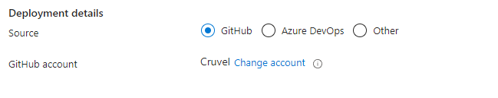

Fill in the details such as resource group, name, organization, repository, branch and change the build presets to custom.

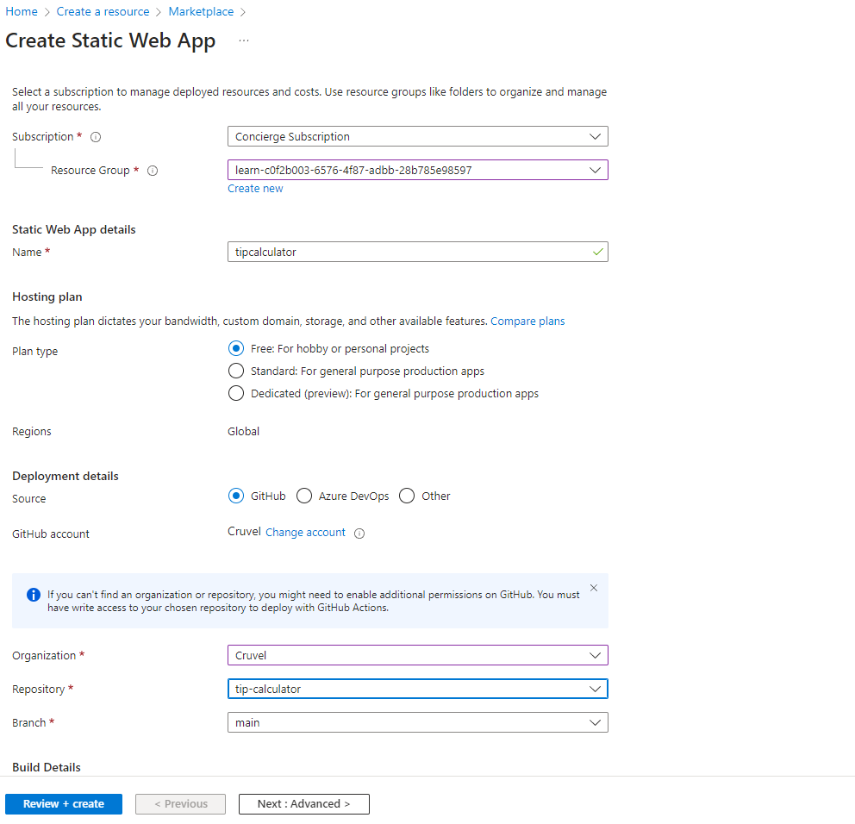

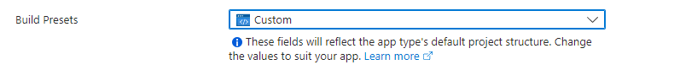

Review the information placed and create the web app.

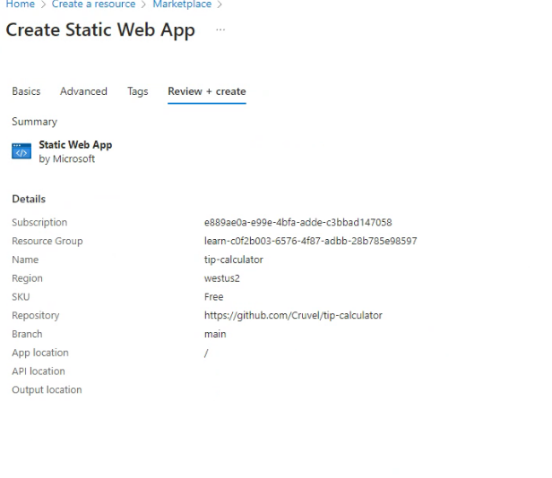

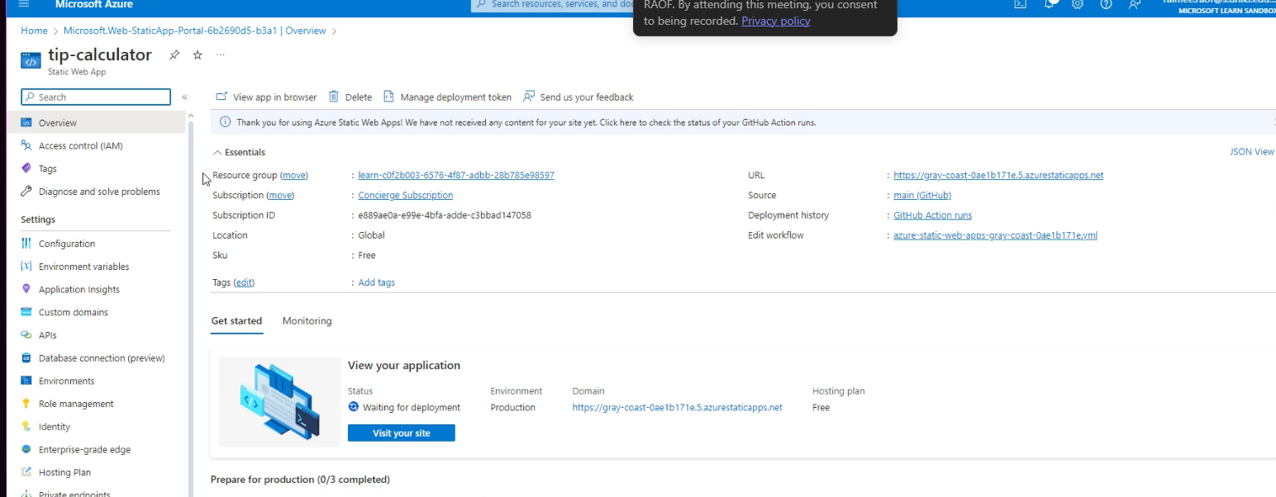

Click GitHub action runs and check to see if the GitHub deployment ready.



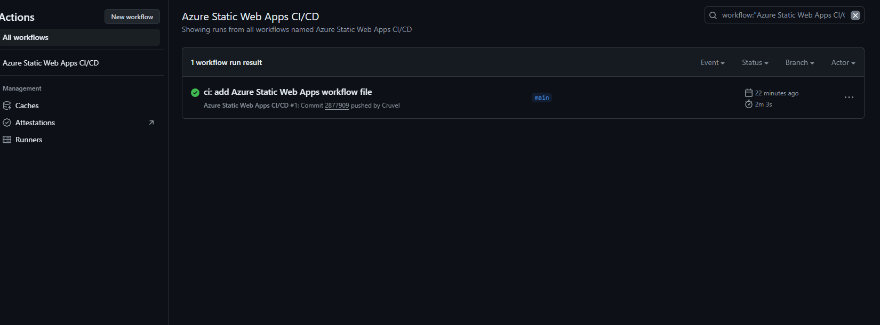

When GitHub action runs are complete, go back to Overview page of the tip calculator static web app azure and click at URL link to view the website that has been deployed.



